Mental Disorders Ontology

(Project Proposal)

Project Code
MDO0741

Project Advisor
Prof. Fahad Maqbool

Project Manager
Dr. Muhammad Illyas

Project Team

- BSEF19M007
  - Rafia Tehseen (Team lead)
- BSEF19M041
  - Toseeq Sarwar (Team Member)

Submission Date
October 20, 2022
Table of Contents
1. Abstract 3
2. Background and Justification 3
3. Project Methodology 4
4. Project Scope 4
5. High level Project Plan 4
6. References 5

Abstract
Around 1-in-7 people globally (11-18 percent) have one or more mental or substance use disorders. Mental Disorders are becoming common day by day due to a lot of environmental factors. Now a day’s field of psychology is thriving and doctors are identifying more and more patients with mental disorders. As mental issues are increasing there is a need to interpret mind and body coordination in the form of ontology ^{[7]}. That’s why there is a need for the machine to understand the mental disorder and their symptoms. In the field of psychology mental disorders are one of the most significant topics. Previously ontology of basic classification of mental disorders was designed by the National Library of Medicine and other than that very little work is done related to providing relevant details of different mental disorders. We are going to design a detailed ontology of mental disorders which will contain all the basic information required to diagnose a disorder like symptoms, types, comorbidity, etc. This ontology will help machines in understanding information related to mental disorders for an effective diagnosis. It could be used by mental health professionals for diagnosis.

Background and Justification
If we look for work related to mental disorders ontology there are the following ontologies designed on a few domains that are related to my topic.
- Mental Disease Ontology ^{[3]}
  - The Mental Disease Ontology explains overall aspects like occurrent, signs, symptoms, etc. of mental diseases. These include the development of a series of classification systems, of which the ICD developed by WHO. Mental Disease Ontology does not include a graphical representation of mental disorders explained and classified in DSM.
- Bipolar Disorder Ontology ^{[1]}
  - The Bipolar Disorder Ontology includes bipolar disorder-related concepts, terms, causes, factors, and different regions that might cause bipolar disorders based on mental functions. It does not explain the symptoms, age group, or comorbidity of bipolar disorders
- Schizophrenia Ontology ^{[2]}
  - The Schizophrenia Ontology explains different types of schizophrenic disorders and their symptoms. This ontology was explained in “Ontologies, Mental Disorders and Prototypes” ^{[10]} in the IACAP 2016 Proceedings. It does not explain any other information necessary for mapping a mental disorder like risk factors, age group, comorbidity, etc.
- Mental Disorder Ontology Classification ^{[9]}
  - This ontology only explains the basic classification of mental disorders. It does not have any details related to mental disorders like their symptoms, types, risk factors, differential diagnosis, etc.
- Posttraumatic Stress Disorder Ontology ^{[5]}
  - This ontology interprets posttraumatic stress disorder as the natural versus artefactual division. It classifies PTSD according to the causal approach. It describes different types of PTSD according to their cause i.e., Natural Kind, Social Construction, or Causal System. It does not explain symptoms age groups, comorbidity, and levels of intensity.
- Sleep Domain Ontology ^{[6]}
  - The Sleep Domain Ontology explains different sleep medicines. It explains sleep medicine in such a way that it explains their unit of measurement, the Quantity they should be used in, their roles, etc. It also explains the symptoms of different types of sleep-domain disorders/diseases. It does not provide a clear classification, risk factors, age group, comorbidity, etc.
- Autism Spectrum Disorder Ontology ^{[8]}
  - The Autism Spectrum Disorder Ontology provides the phenotype for diagnoses of autism spectrum and related neurodevelopment disorders using their classification, risk factors, and comorbidity. It could be extended by adding the level of intensities, age group, and ICD code for disorders, etc.
This present ontology is going to contribute to this domain by designing a detailed ontology on mental disorders. It will explain basic mental disorders, their types, ICT code, symptoms, etc. discovered till now by using the Diagnostic and statistical manual of mental disorders ^{[4]}. Our ontology will help mental health professionals in making a better diagnosis of mental disorders based on their signs and symptoms.

Project Methodology
We will design mental disorder ontology using NEON Methodologies. We will take the following steps to design our ontology:

Determine the domain and scope of the ontology. (ORSD)

Consider reusing existing ontologies.

Writing ontology review document

Enumerate important terms.

Define the classes & class hierarchy.

Define the properties (Object and Data) of classes.

Create instances.

Write SPARQL queries to answer contemporary question

Project Scope
The ontology has to focus just on the different types of mental disorders in this domain and their symptoms, types, risk factors, correlation, etc. The level of granularity is directly related to the competency questions and terms identified.

High-level Project Plan
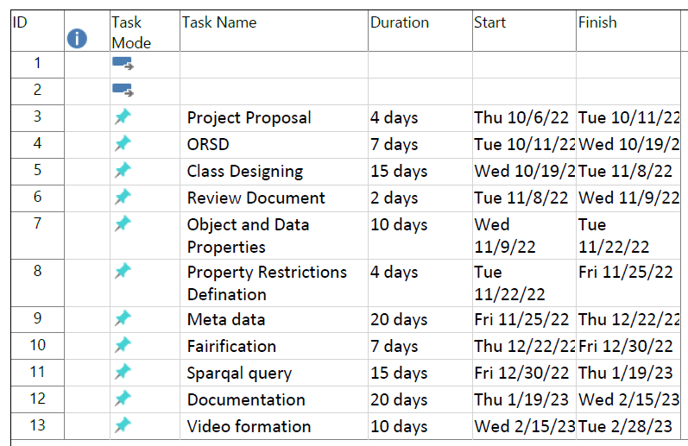

References
- Zhang, B. (2022). GitHub - SCAI-BIO/bipolar-disorder-ontology: Bipolar Disorder Ontology. Retrieved 19 October 2022, from https://github.com/SCAI-BIO/bipolar-disorder-ontology#bipolar-disorder-ontology
- Amoretti, C., Frixione, M., Lieto, A. and Adamo, G., 2022. Schizophrenia_Spectrum Ontology. [online] Di.unito.it. Available at: <http://www.di.unito.it/~lieto/Schizophrenia_Spectrum.owl> [Accessed 19 October 2022].
- Service, O. (2022). Mental Disease Ontology < Ontology Lookup Service < EMBL-EBI. Retrieved 19 October 2022, from https://www.ebi.ac.uk/ols/ontologies/mfomd#:~:text=The%20Mental%20Disease%20Ontology%20is,Mental%20Functioning%20Ontology%20(MF).
- American Psychiatric Association, 2013. Diagnostic and Statistical Manual of Mental Disorders, Fifth Edition: DSM-5. Washington, DC: American Psychiatric Publishing.
- McNally, R. J. (2012). The ontology of posttraumatic stress disorder: Natural kind, social construction, or causal system? Clinical Psychology: Science and Practice, 19(3), 220–228.
- Arabandi, S. (2015, March 26). Sleep domain ontology: NCBO Bioportal. Retrieved October 18, 2022, from https://bioportal.bioontology.org/ontologies/SDO
- Okafor, G., 2022. Ontology: The Basis of the Mind-body Problem. International Journal of Scientific and Management Research, 05(02), pp.236-248.
- Mugzach O, Peleg M, Bagley SC, Guter SJ, Cook EH, Altman RB. An ontology for Autism Spectrum Disorder (ASD) to infer ASD phenotypes from Autism Diagnostic Interview-Revised data. J Biomed Inform. 2015 Aug;56:333-47. doi: 10.1016/j.jbi.2015.06.026. Epub 2015 Jul 4. PMID: 26151311; PMCID: PMC4532604.
- Service, O. (2022). mental disorder. Retrieved 19 October 2022, from https://www.ebi.ac.uk/ols/ontologies/mfomd/terms?iri=http%3A%2F%2Fpurl.obolibrary.org%2Fobo%2FMFOMD_0000004
- Amoretti1, C., Frixione, M., Lieto, A. and Adamo, G., 2022. Ontologies, Mental Disorders and Prototypes. IACAP 2016 Proceedings., [online] p.21. Available at: <https://philarchive.org/archive/AMOOMD> [Accessed 19 October 2022].

